Classwork 6.1

Take a look at MiamiHeat… what are the cases?

Let’s use Points as the outcome variable.

* Which of these other variables might help explain some of the variability in Points?
  + Histogram:
    - gf_histogram(~ Points, data = MiamiHeat, fill = "orange")
    - What is on the y-axis? (PE)
    - Where is the variation in points? (Gesture)
  + Scatterplot:
    - gf_point(Points ~ Assists, data = MiamiHeat, size = 4, color = "darkgreen")
    - Where is the variation in points? (Gesture)
* Write a word equation. Describe the story of your DGP.
* Explore the relationship graphically.
  + If you haven’t yet, explore a relationship between Points and a quantitative explanatory variable.
* What would the empty/null model be that we could compare to our explanatory story?
  + Write empty model as a word equation
  + Write in General Linear Model (GLM) notation (those are the ys and bs, etc)
* Fit the empty model
* Put the empty model graphically onto your visualization
  + Histogram: **variation in data = model + error**.
    - Where is the model? Where is the error? (Gesture)
  + Scatterplot:
    - Where would you draw the empty model on the scatterplot? (PE)
    - Where is the error? (Gesture)

DGP:

* Story: Assists help us predict Points; Points = Assists + error (this is other stuff… randomness, stuff we haven’t included yet -- health of team, how good defense of other team, etc)
* Only random: Points = mean + error (this is ONLY other stuff...  randomness, stuff we haven’t included yet)

Empty model:

* If you are using the empty model but you know that a game had a lot of Assists, what would you predict the Points to be? (PE)
* Let’s make predictions from the empty model
* What would it look like if we graphed Predicted by Assists?
  + gf_point(Predicted ~ Assists, data = MiamiHeat, color = "green3",size = 4)
* When we fit the empty model, have we “explained” any of the variation?
  + 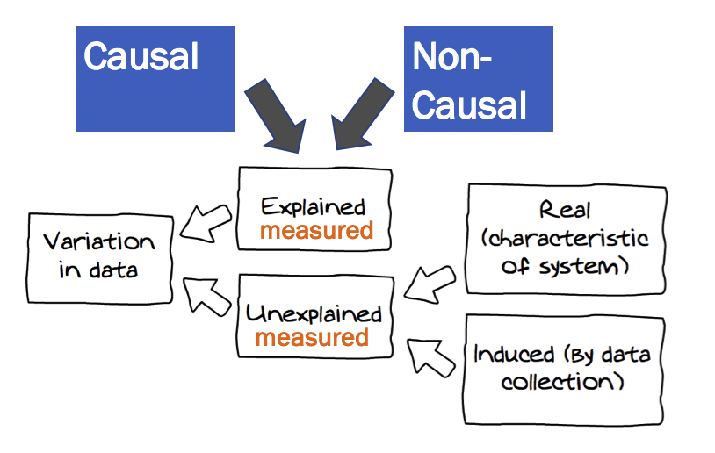
  + 0% of error explained. All the model does is REVEAL the error (residuals). If you have a model, all of a sudden you have error. Before we just had variation.
  + Contrast:
    - Null model: variation in Points = mean + error (0% of variation explained)
    - Assists model: variation in Points = Assists + error (???% of variation explained?)
    - It would help to know how much error exists so that we can figure out how much of it has been explained when we add in Assists… QUANTIFYING ERROR - chapter 6!